**WEEK-5**

**Day - 1 : 12 February 2024**

**News Master Website**

**In this I created different html pages with different news categories like Top**

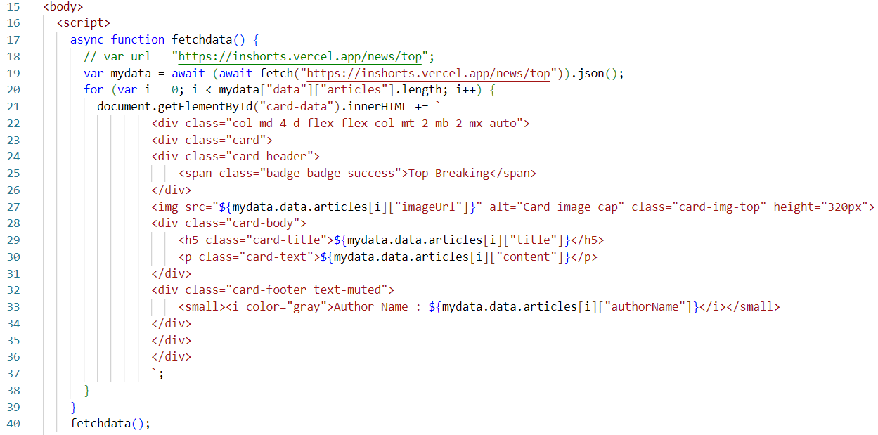

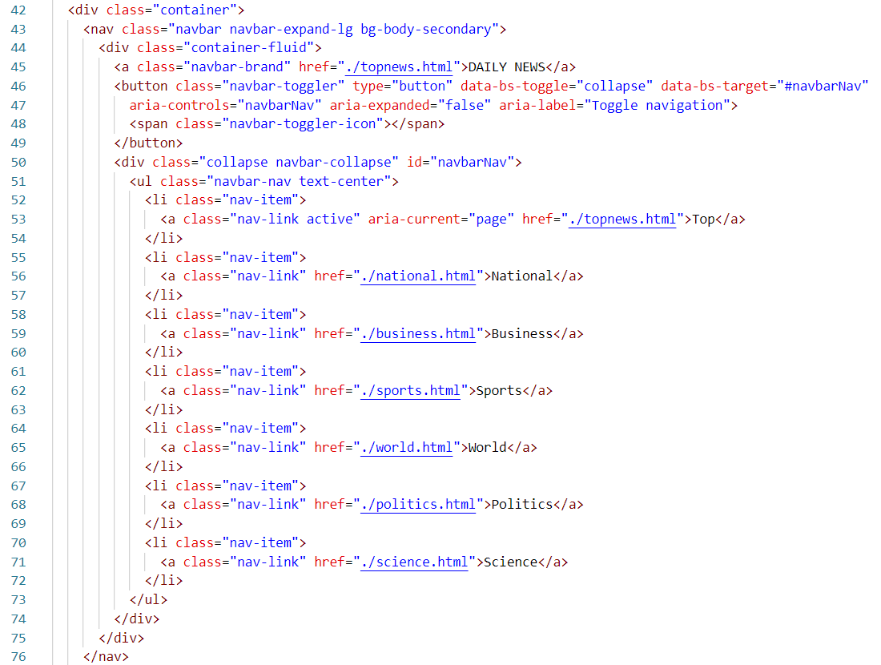

**Output :**

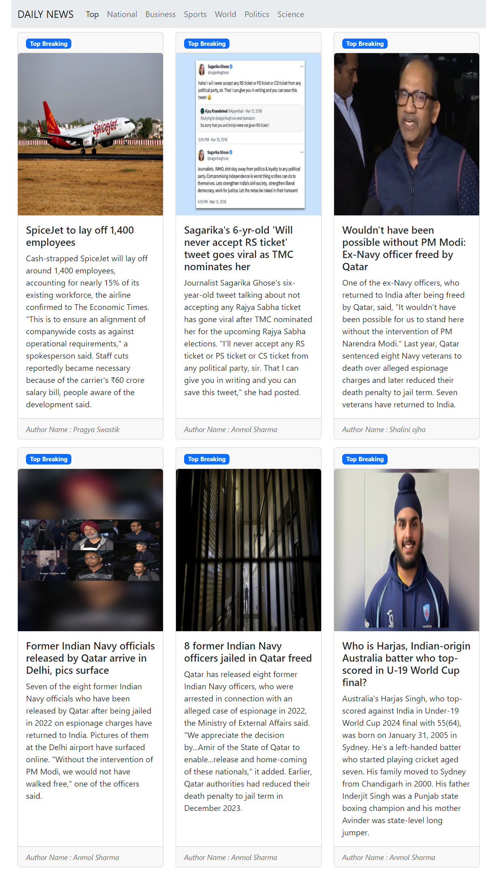

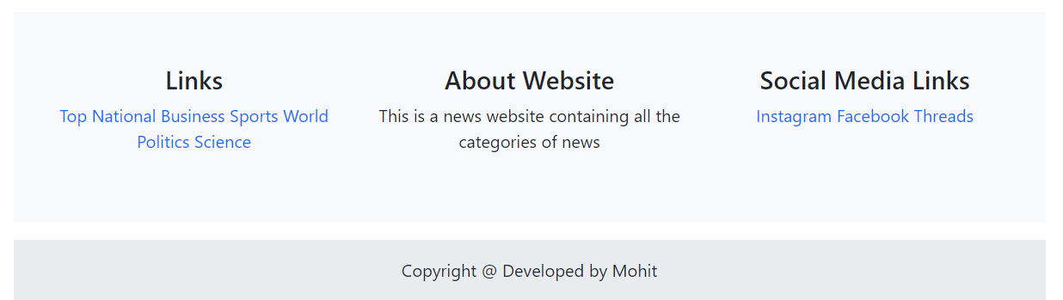

**Day-3 : 14 February 2024**

**React-routing using react-router-dom**

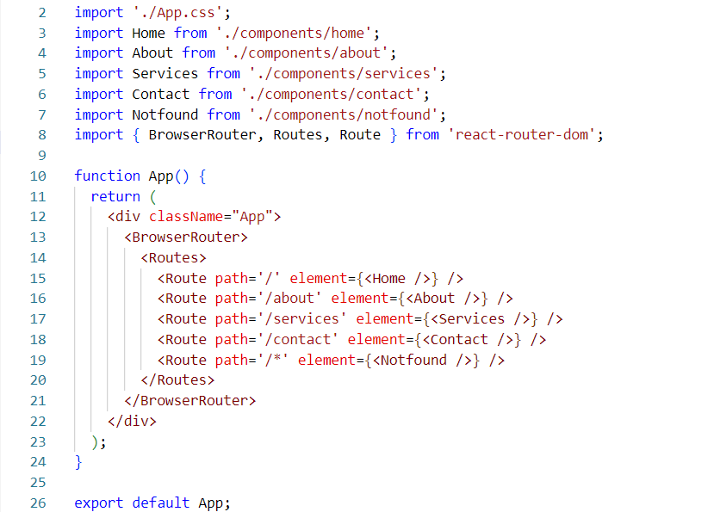

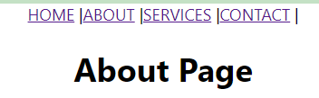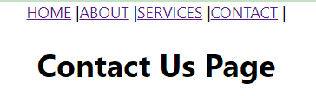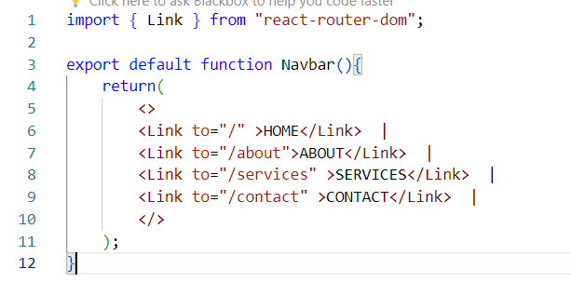

**Also from assignment-1 , we have to prepare a react project using the react-router that routes us to different pages like Home, About, Services, Contact etc….**

**Output of that project looks like…**

